Climate: Humid Tropical

Major weather patters: warm and rainy all year

Vegetation: rain forest

Animals in that region: bats, tree frogs, monkeys, jaguars, tigers, snakes and parrots.
-------------------------------------
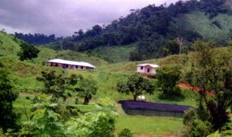

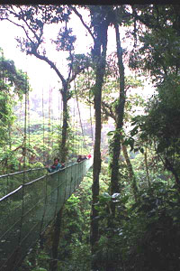

Climate: tropical savanna

Major weather patters: warm all year, rainy with dry seasons

Vegetation: grassland with scattered trees

Animals in that region: anacondas, lions, elephants, gazelles, ostriches, hyenas, rhinoceroses, zebras
-------------------------------------

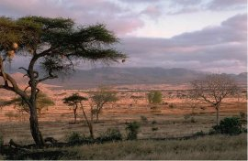

Climate: desert

Major weather patters: dry and sunny with rainy and dry seasons

Vegetation: a few hardy plants such as cacti

Animals in that region: lizards, scorpions, snakes, bats, bobcats, coyotes
-------------------------------------

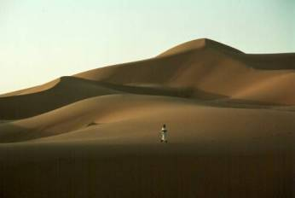

Climate: Steppe

Major weather patters: hot summers with cooler winters

Vegetation: grassland and a few trees

Animals in that region: antelope, wild horses, kangaroos, coyotes, camels
-------------------------------------

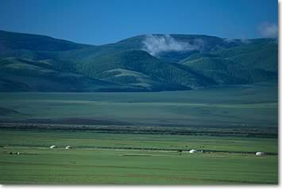

Climate: Mediterranean

Major weather patters: dry, sunny, warm winters and mild, wetter winters

Vegetation: scrub woodland and grassland

Animals in that region: deer, elk, mountain Lyons, wolves
-------------------------------------

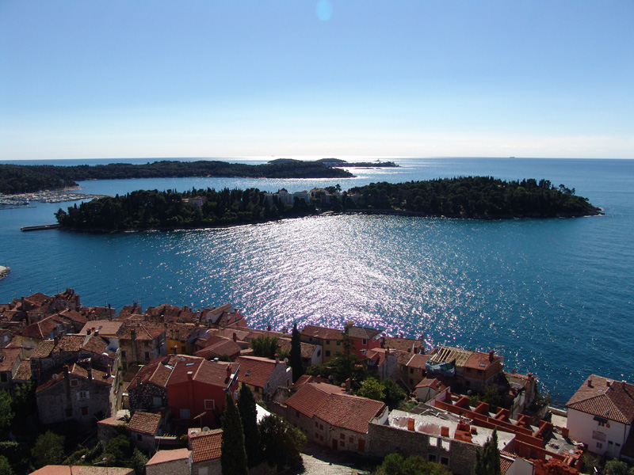

Climate: humid subtropical

Major weather patters: humid summers and mild winters; rain all year

Vegetation: mixed forest

Animals in that region: alligators, dear, bear, squirrels, foxes, snakes, birds
-------------------------------------
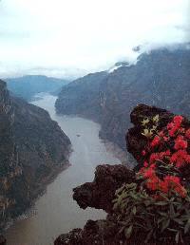

Climate: marine west coast

Major weather patters: cloudy, mild summers and rainy winters

Vegetation: evergreen forests

Animals in that region: wild boar, deer, bear, seals
-------------------------------------
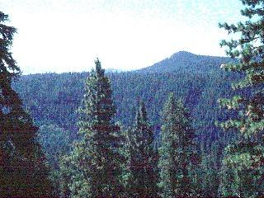

Climate: humid continental

Major weather patters: long winters and short, warm summers

Vegetation: mixed forest

Animals in that region: wolverines, wild boar, deer
-------------------------------------

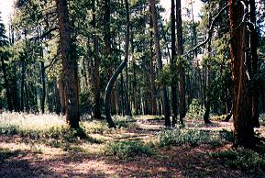

Climate: sub arctic

Major weather patters: long, cool winters and short, warm summers

Vegetation: evergreen forests

Animals in that region: rabbits, mouse, elk, wolves, lynxes, bears
-------------------------------------

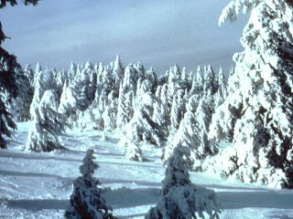

Climate: tundra

Major weather patters: cool all year, little precipitation

Vegetation: moss, lynches, low scrubs, marshes

Animals in that region: rabbits, reindeer, wolves, fox
-------------------------------------
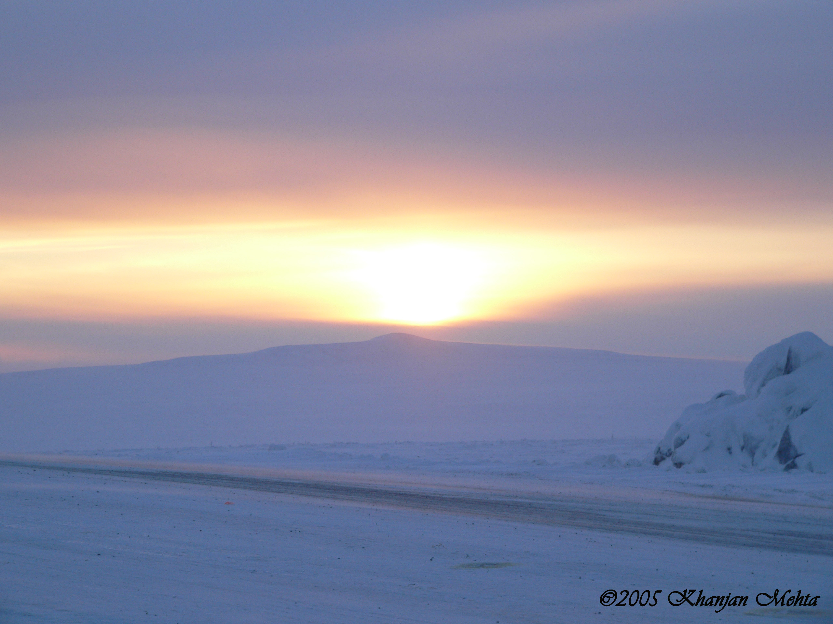

Climate: ice cap

Major weather patters: freezing cold all year

Vegetation: none

Animals in that region: polar bears, penguins, seals
-------------------------------------
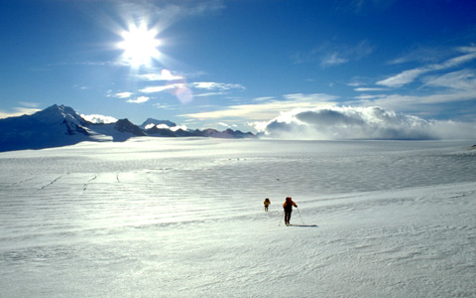

Climate: highland

Major weather patters: wide range of precipitation and temperature depending on elevation

Vegetation: forest tundra vegetation

Animals in that region: wide range depending on elevation
-------------------------------------

